PHASE 6 – PROJECT TESTING
Project Title
Import Data using Transform Maps (Spreadsheet)

1. Introduction
Testing is an important stage of the project development process. It is performed to verify that the employee data import process works correctly in ServiceNow. The testing process checks the Import Set, Transform Map, field mappings, Coalesce configuration, data transformation, and the resulting employee records.
The project was tested using spreadsheet data containing employee information such as Employee ID, Employee Name, Email, Department, and Location.

2. Testing Objectives
The main objectives of testing are:
- To verify that employee data can be imported from the spreadsheet.
- To verify that data is loaded correctly into the Employee Import table.
- To verify that the Transform Map works correctly.
- To verify that source fields are mapped to the correct target fields.
- To verify that Employee ID is configured as the Coalesce field.
- To verify that existing employee records can be updated.
- To verify that new employee records can be inserted.
- To verify that transformed data is stored correctly in the Employee Test table.
- To verify that employee reports display the required information.
- To verify the Employee Analytics Dashboard after its completion.

3. Unit Testing
Unit testing was performed on the individual components of the project to ensure that each component functions correctly.
Test ID | Component | Test Description | Expected Result | Result
UT-01 | Employee Test Table | Verify the target table and fields | Required fields are available | Pass
UT-02 | Employee Import | Load spreadsheet data | Data is loaded successfully | Pass
UT-03 | Transform Map | Verify source and target tables | Correct tables are selected | Pass
UT-04 | Field Mapping | Verify source and target mappings | Fields are mapped correctly | Pass
UT-05 | Coalesce | Verify Employee ID configuration | Employee ID identifies existing records | Pass
UT-06 | Transformation | Run the Transform Map | Records are transformed successfully | Pass

4. Integration Testing
Integration testing verifies whether the different components of the system work together correctly.
The complete data flow was tested as follows:
Employee Spreadsheet
↓
Employee Import
↓
Sample Spreadsheet Import
↓
Field Mapping
↓
Employee ID Coalesce
↓
Employee Test
The testing confirmed that employee information could be loaded into the Import Set and transformed into the Employee Test target table.
Integration Test Cases
Test ID | Test Case | Expected Result | Result
IT-01 | Import spreadsheet into Employee Import | Spreadsheet data is loaded successfully | Pass
IT-02 | Run Transform Map | Employee records are transformed successfully | Pass
IT-03 | Verify field mapping | Data appears in the correct fields | Pass
IT-04 | Verify Employee ID Coalesce | Existing records are identified correctly | Pass
IT-05 | Verify Employee Test table | Transformed records appear in the target table | Pass

5. Validation Testing
Validation testing was performed to verify that the imported employee information matches the original spreadsheet data.
The following fields were checked:
- Employee ID
- Employee Name
- Email
- Department
- Location
The values in the Employee Test table were compared with the corresponding values in the spreadsheet.
Test ID | Field Tested | Expected Result | Result
VT-01 | Employee ID | Matches the spreadsheet data | Pass
VT-02 | Employee Name | Matches the spreadsheet data | Pass
VT-03 | Email | Matches the spreadsheet data | Pass
VT-04 | Department | Matches the spreadsheet data | Pass
VT-05 | Location | Matches the spreadsheet data | Pass

Figure 2: Employee Test Records After Transformation
→ Screenshot showing the imported records in the Employee Test table.
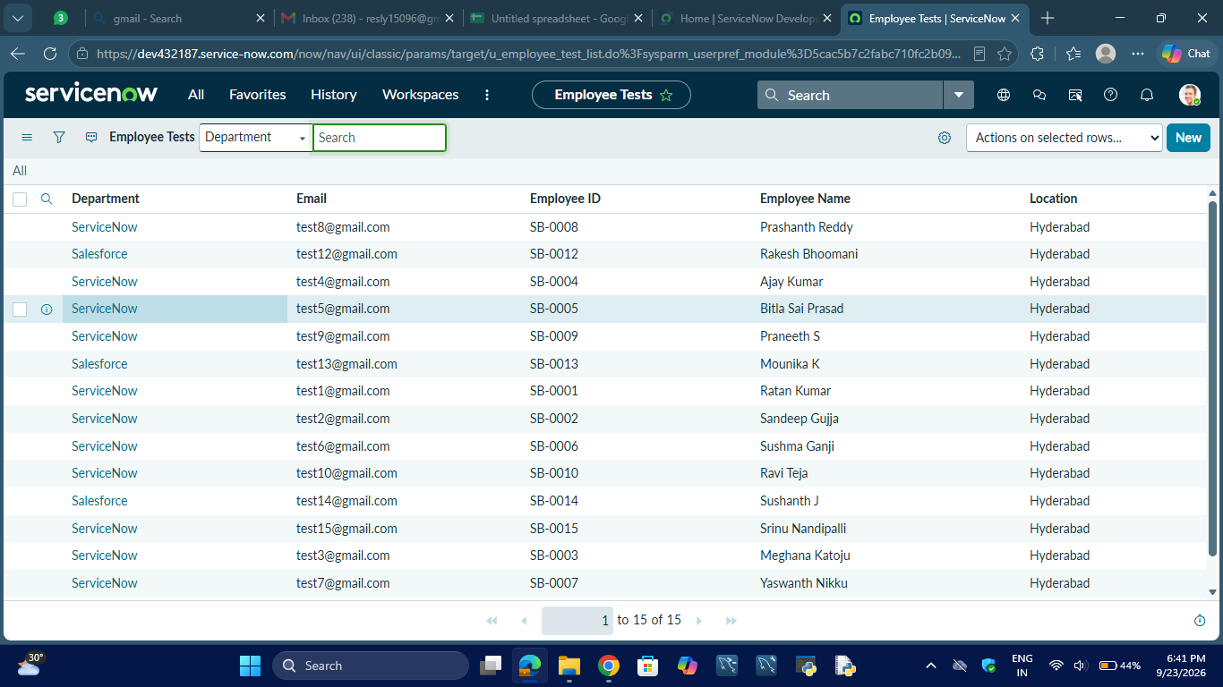

6. Coalesce Testing
The Employee ID field was configured as the Coalesce field in the Transform Map. Testing was performed to verify that the system can identify existing employee records using the Employee ID.
Existing Record Test
An employee record with an existing Employee ID was used during testing.
Expected Result:
The existing employee record should be updated instead of creating a duplicate record.
Result: Pass.
New Record Test
A new employee record with a new Employee ID was used during testing.
Expected Result:
A new employee record should be inserted into the Employee Test table.
Result: Pass.
The testing confirmed that the Coalesce configuration supports both updating existing records and inserting new records.
Figure 3: Transform History
→ Screenshot showing the Transform History and inserted/updated records.
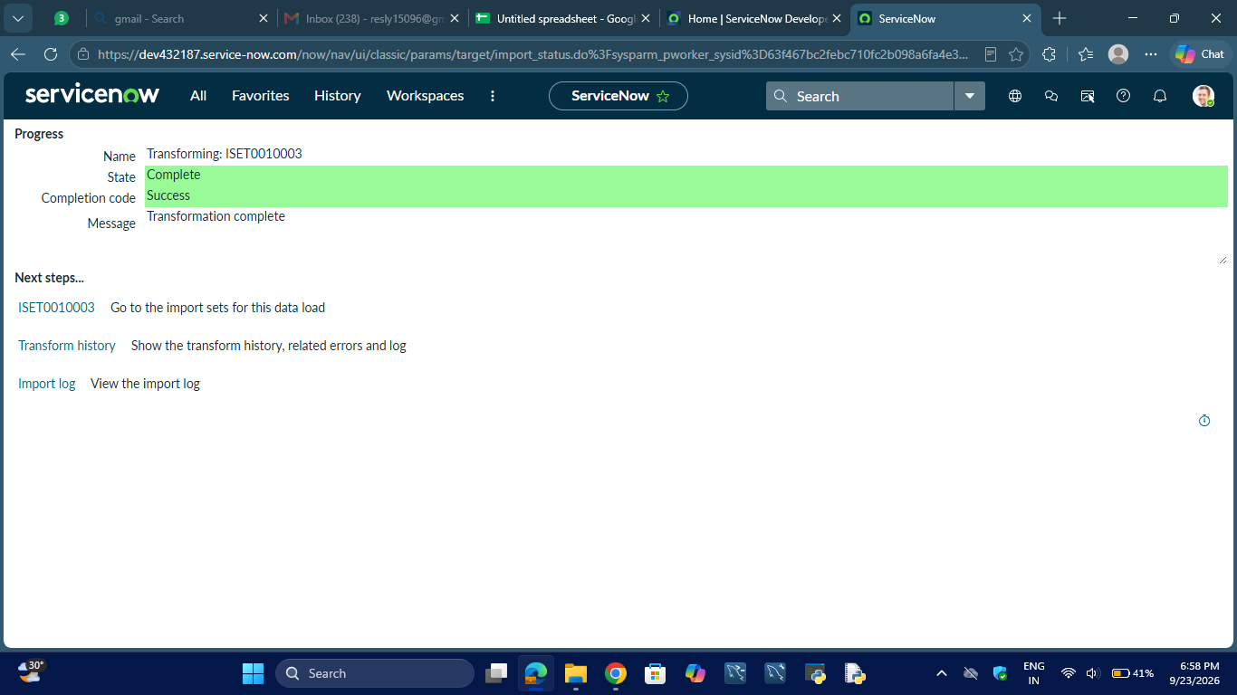
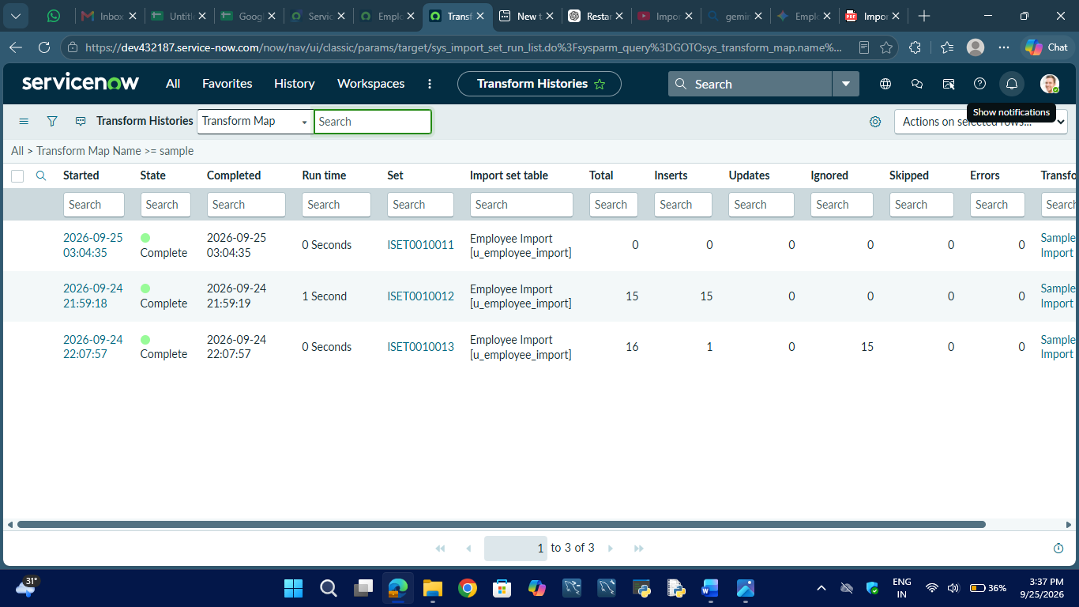
Figure 4: Update and Insert Test Result
→ Screenshot showing the result of the update/insert test.
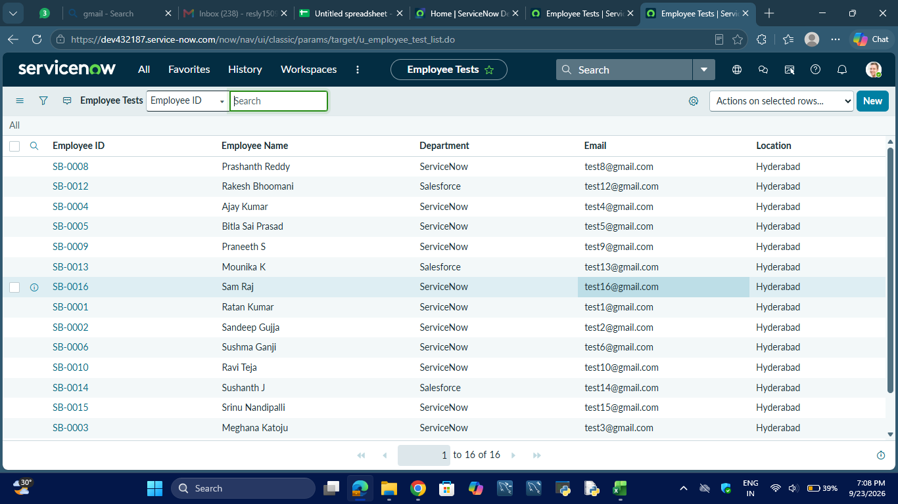

7. Transform Testing
The Transform Map was executed to verify the complete transformation process.
The following items were checked:
- Source table — Employee Import
- Target table — Employee Test
- Transform Map — Sample Spreadsheet Import
- Field mappings
- Employee ID Coalesce
- Transformation result
The transformation completed successfully and the employee records were available in the Employee Test table.

Figure 1: Successful Transform Result
→ Screenshot of the successful Transform operation.
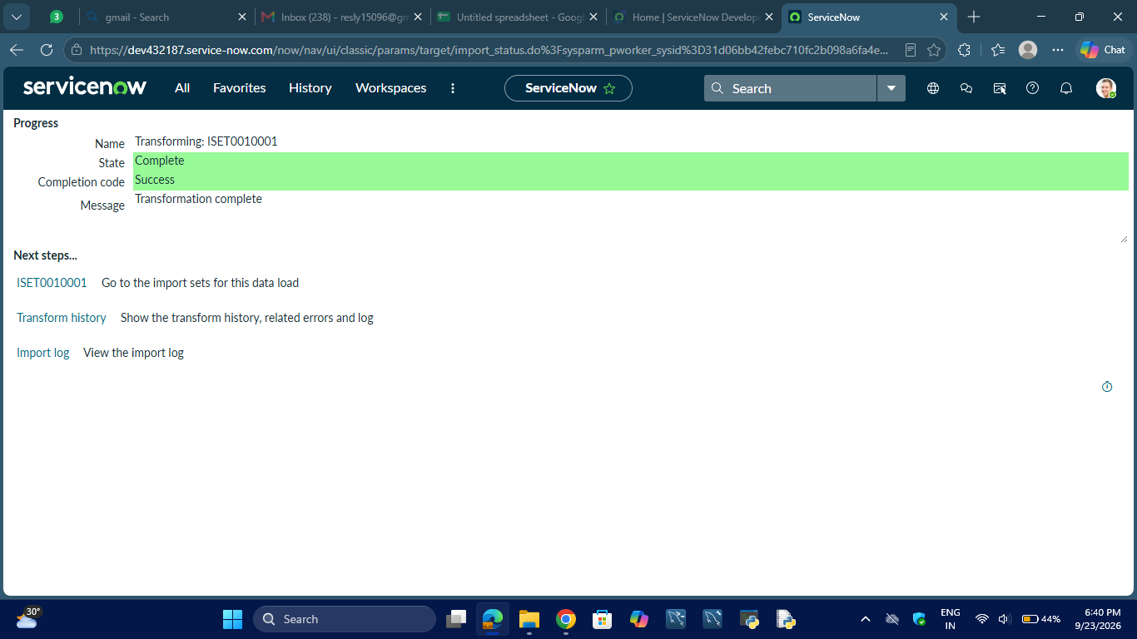

8. Report Testing
The employee reports were tested to verify that the imported employee data can be displayed correctly.
8.1 Employees by Department
The report was tested to verify that employees are grouped according to their departments and that the employee count is displayed correctly.
Expected Result:
The report should display the number of employees for each department.
Result: Pass.
Figure 5: Employees by Department Report
→ Department pie chart.
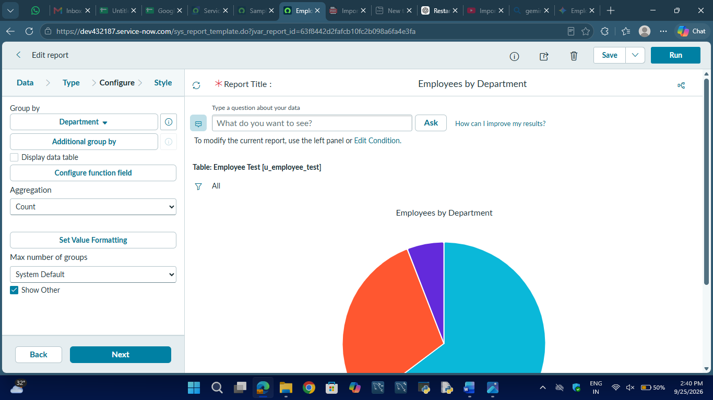

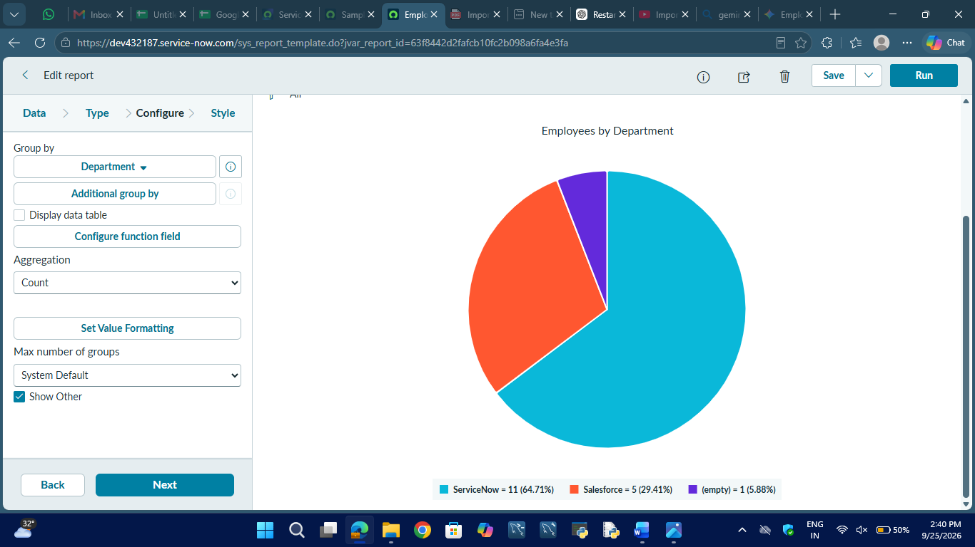
8.2 Employees by Location
The report was tested to verify that employees are grouped according to their locations.
Expected Result:
The report should display the number of employees for each location.
Result: Pass.
Figure 6: Employees by Location Report
→ Location bar chart.
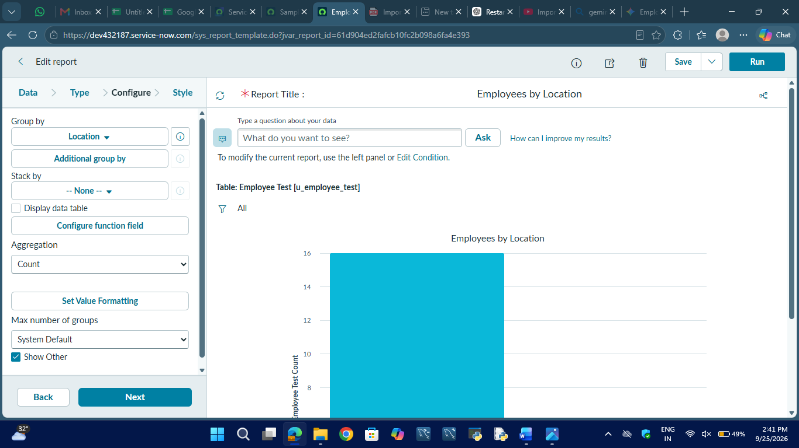

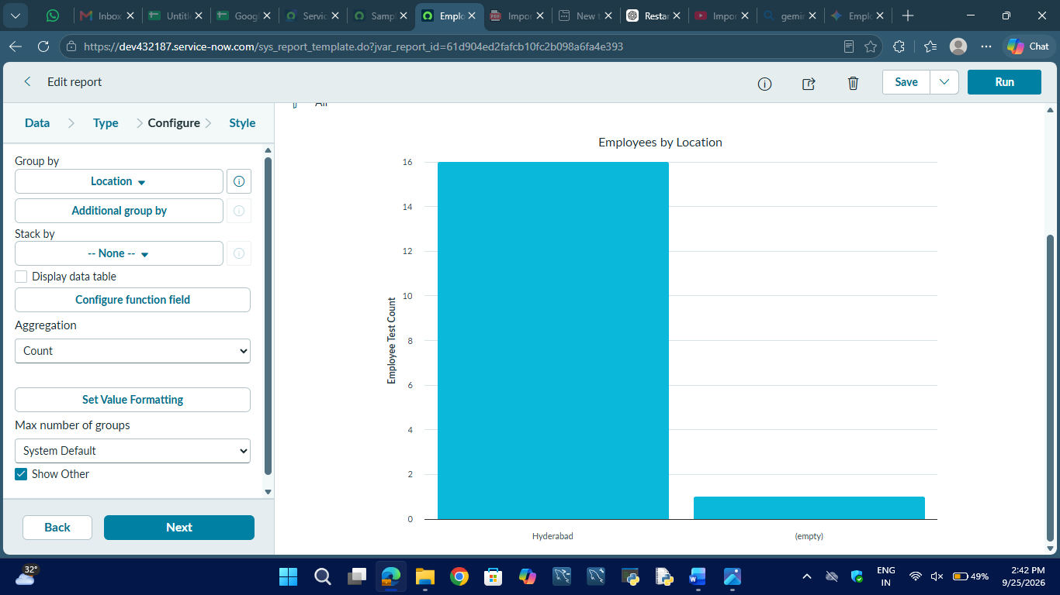

8.3 Employee List Report
The list report was tested to verify that the following fields are displayed:
- Employee ID
- Employee Name
- Email
- Department
- Location
Expected Result:
The employee information should be displayed correctly in list format.
Result: Pass.
Figure 7: Employee List Report
→ Employee list showing the required fields.
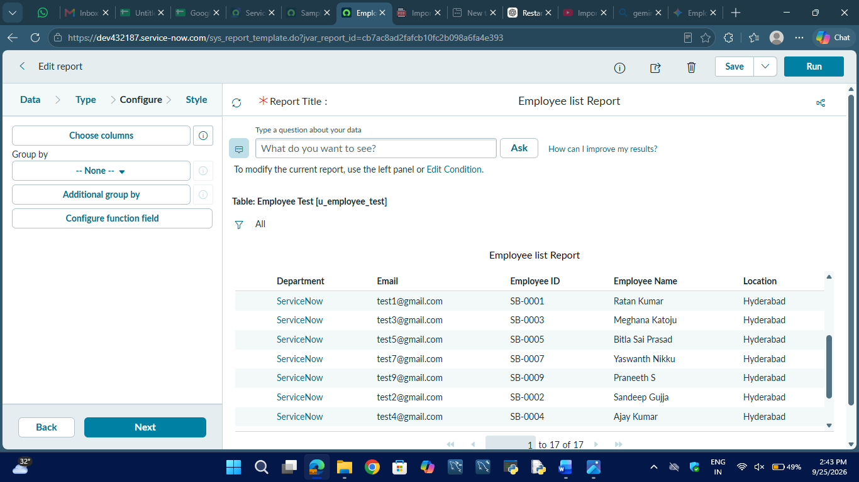
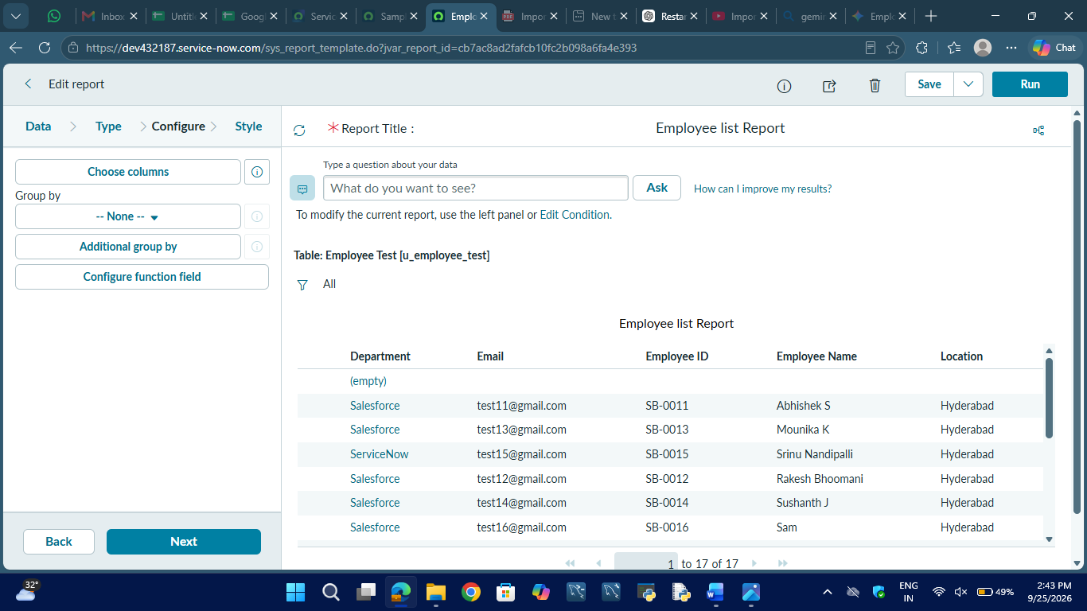

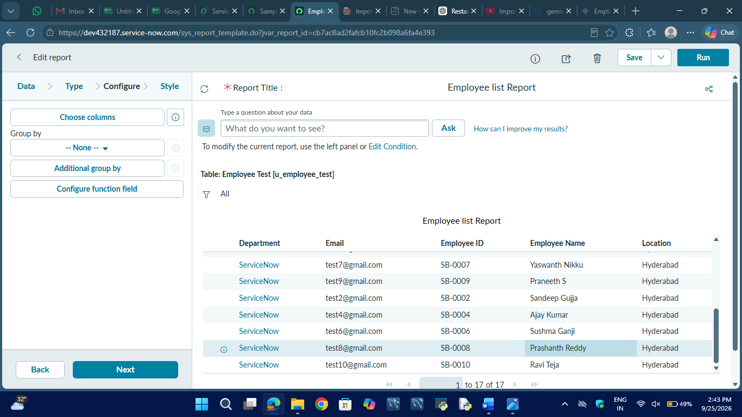
The project guide specifies these three reports as part of the reporting stage.

9. Dashboard Testing
The Employee Analytics Dashboards was designed to provide a centralized view of employee information.
The dashboard is intended to contain:
- Employees by Department
- Employees by Location
- Employee List
Each dashboard element will be checked to verify that it displays the correct employee information.
Expected Result:
The dashboard should display the required employee analytics correctly.
The Employee Analytics Dashboard was tested after adding the required employee analytics elements. The dashboard provides a centralized view of employee information through the Employees by Department, Employees by Location, and Employee List components. The dashboard was verified to ensure that the configured elements display the employee data correctly.
Result: Pass
Figure 8: Employee Analytics Dashboard
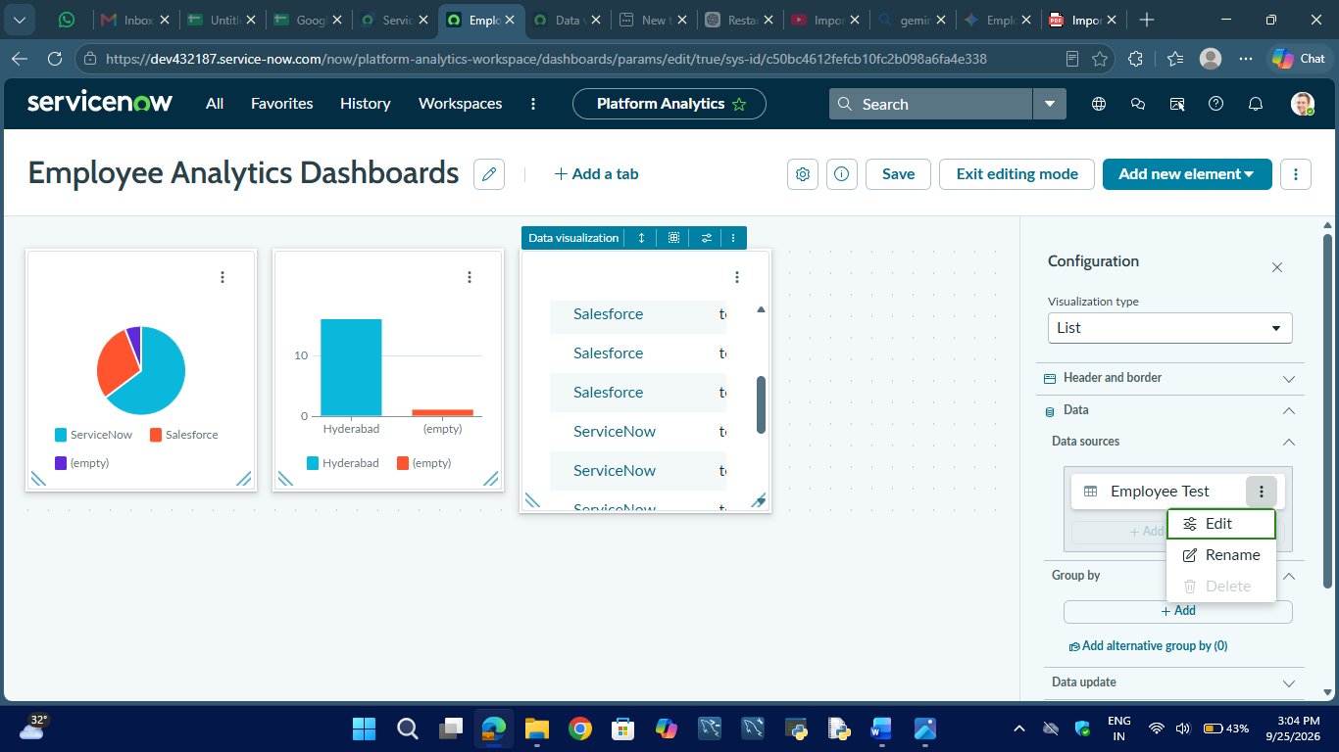

10. Overall Test Result
The testing process verifies the major functions of the Import Data using Transform Maps (Spreadsheet) project. The Import Set, Transform Map, field mappings, Coalesce configuration, transformation process, and employee records were tested.
The testing confirms that the system can import employee information from a spreadsheet and transform it into the Employee Test table.

11. Conclusion
The testing phase ensures that the developed ServiceNow solution performs the required employee data import and transformation operations correctly. Unit testing verifies individual components, integration testing verifies the complete data flow, and validation testing verifies the accuracy of the imported employee information.
The testing process also verifies the update and insert functionality using Employee ID as the Coalesce field. The reports and dashboard are tested to ensure that employee information can be presented clearly for analysis.

